Change Request
Subject | Eventum Replacement
Requester
Requester Department
Ref. Project Name | New Eventum
Ref. Project Manager | Nada Mohammed
Date | June-2022
Received By | Nada Mohammed

Change Main Info
Application Name: Eventum
Module Name:
Screen/Report Name:
Change Type: (put a mark beside the changes types)
 | Bug |  | Appearance modification |  | Business logic modification
 | add new fields |  | add new reports |  | add new screens
 | add new modules |  | Other

Amendment History
Version | Issue Date | Author(s) of changes | Details of Changes made
0.1 |  | Nada Mohammed | Initial CR Document
0.2 |  | Nada Mohammed | 1-business user section  Point 2  Point D in number 4  2- CR creation section  3- CR journey 2nd point  4- workflow VISIO  5- Notes section
0.3 |  | Nada Mohammed | - Point 5 in the login page  - New Section for pages’ contents.  - Removed business user section  - Point 5 & 6 in business validation for legacy CR  - Point 2 in Technical estimation  - Add Status & permission on technical fields for each group.  - Add Pages permissions for each group.  - Notes section.  - Attachment section.

Description

Desired Behavior:

Login Page:
- Login Screen will contain 2 fields: user name, password.
- Users from Telecom Egypt & outside should have access to this system.
  - User from Telecom Egypt should be able to via active directory (Cairo domain & Egypt Domain).
- Users from our side Telecom Egypt can access this system via local user created especially for this system.
- Users will be divided into (Business user, Technical user).
- After login successfully a page contains tabs (My CRs, Search, Advanced search, create new CR, MY assignments, reports) “this will appear to admin user”
  - List of permissions for each tab for every group attached except:
    - Create new CRs will be available for any one.
    - Reports & Advanced Search will have a standalone permission for specific users only.

Pages Content

Create New CR
When any user tab on create new CR another page will appear to add the new CR data as below:
  - Creator Information contains: creator name, creator e-mail, department (will retrieve data from active directory automatic).
  - Creator will choose division manager from a pre- configured Mandatory drop down menu.
  - Category (mandatory drop down menu => Bug, Feature Request, Automated Report, Hot fix, New marketing service, New report, Update existing report, Ongoing).
  - If user chooses on going CR another mandatory drop down menu “Parent ID” will appear for user to choose it “this drop down menu will be configured & editable by admin in the back end”.
    - Another read only field will appear with system related to the chosen parent ID by user.
    - Admin user can configure the list by adding the Parent CR ID, active/ in active status, related system.
    - If admin chooses inactive status for parent CR ID, it will disappear from the parent CR list for the normal user to choose.
    - Only active Parent ID CRs will appear in the parent ID list.
  - CR subject (mandatory text field).
  - CR description (mandatory text field).
  - Targeted system (mandatory pre-configured drop down menu).
  - Optional field for attachments, with max size 30M per file and user can every user can upload max 20 files, also all types allowed to be uploaded except exe.
    - User can upload one file at a time or multiple files.
  - Numeric mandatory field for user to add his contact mobile number.
  - Once CR is submitted CR ID will appear and all fields will be dimmed for user and can’t be edited except the description field which can be edited as long as the CR is pending L3 approval.
  - In my CRs page user will be able to show his CRs in rows with columns: CR number, subject, current status, creation date, system
  - Add filtration for user to be able to filter the home page CRs/CR list for each column in those pages to be able to filter each column and all result appear (like excel)
  - In the CR page creator can see CR subject, summary, targeted System, CR number, Current Status, Creation Date, Delivery Date.
  - Status mapping for high level status which will appear to business user:

High level status | CR status
Business Approval | Business approval
Pending CAB | Pending CAB
 | Pending Test Case approval
 | Review the CR document
Technical Validation | CR Estimation
 | Business Validation
 | Required info
 | Design Estimation
 | Dev Estimation
 | Testing Estimation
 | CR Scope Defining
In progress | Pending Design
 | Pending Implementation
 | Pending Testing
 | Technical Design
 | Technical implementation
 | Require CR document
 | CR Document Updates
 | Release Plan review
 | Estimation Negotiation
 | Release Planning
 | Release Plan negotiation
 | Test cases review and modifying
 | CR Implementation
 | Rework
 | Test In progress
UAT | UAT in Progress
 | UAT activities
 | UAT approval
Production Deployment | pending Capacity Approval
 | Pending production deployment
 | Sanity Check
Delivered | Delivered
Rejected | Rejected

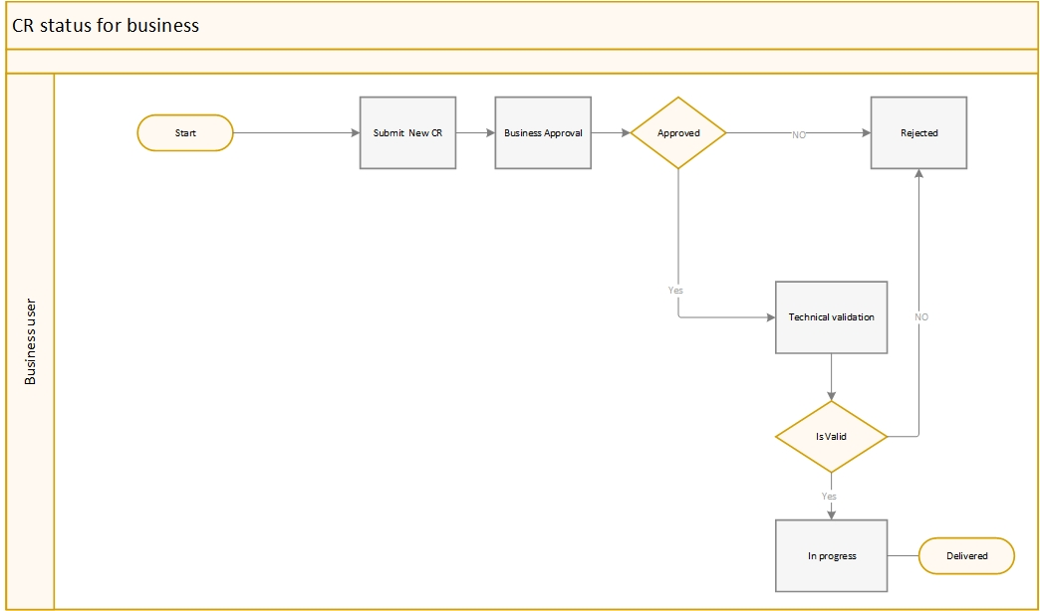

My CRs
List of CRs created by the user will appear in this page:
- 10 records per page will appear.
- A Search bar will be available and one the user tab any work in this search bar all results will appear below.
- Results columns:
  - CR ID creation date Subject Current Status Application Name View CR

My Assignments
- Will be available for all technical teams only.
- 10 records by page will appear.
- A Search bar will be available and one the user tab any work in this search bar all results will appear below.
- In this page only CRs assigned for this user will appear.
- Result columns:
  - CR ID Subject Current Status Application Name View CR

Search
- A search bar/ tab will be available for user to search by CR ID
- Once the user enters the CR ID and press on search the CR details page will appear for the user.
- Every user can find his own created CRs only except for specific users with standalone permission can find any CR.

Advanced Search
- This Tab will appear to specific users with standalone permission.
- 20 record per page will appear.
- User can save the entered search criteria as a saved view to be able to run the same search any time he presses on the saved search.
- User can choose one filter or more and all results matching this filter will appear.
- Every user can make search view by:
  - Key words
  - CR status.
  - CR ID
  - CR category
  - Assigned user.
  - Assigned group.
  - Duration from & to “can be chosen from calendar”
  - Release CR
  - Assigned Unit
  - Testable
  - Relevant CRs
  - Legacy CRs
  - Ongoing CRs
    - Child CRs
    - Parent CRs
  - Vendor CRs
  - Depend On CRs
  - Need Design
  - Release Delivery Date
    - Release Name Duration or specific date
  - Release receiving Date
    - Duration or specific date
  - Need IOT/E2E testing
  - TE Testing Date
    - Duration or specific date
  - UAT Date
    - Duration or specific date
  - Vendor name
  - Man Days
    - Has man days
    - Or entering specific number of man days
  - Cost
    - Specific cost
    - Cost range
    - Has cost
  - Targeted system
  - Can filter by estimation duration for Design, Dev, test separately.
  - Change Requester.
  - Requestor Division Manager
  - Change Requester E-mail
  - Requesting Department
  - CR Manger
  - Responsible Designer
  - Responsible Developer
  - Responsible Tester

CR journey:
- Any created CR after creation the status will be turned to business approval in the CR management Pool.
- After L3 approval via the notification mail and while the CR is business approval in CR management pool, CR Manger Admin will choses if project CR via an optional check box field and if chooses project CR another mandatory drop down menu (pre-configured with all project names) appears to choose project name.
- After the CR is passed L3 approval system will assign the CR to CR Analyst based on the targeted system.
  - CR analyst list will be based on pre-configured list connected to each system.
- Attachment field will always be available to add attachments as long as the CR is opened and can be viewed by CR Manger & business users
- Another technical attachment field will be available as long as the CR is opened and can be viewed by CR & technical users.
- 4 automatically updated fields will appear in the CR page:
  - CR Manger
  - Responsible Designer
  - Responsible Developer
  - Responsible Tester

Legacy CR:

Business Validation:
- In Business validation status the CR will be assigned in CR management Pool, CR Manager can add his analysis feedback in a free text field “analysis feedback” and this field will be visible to all users as read only except any CR Manager user.
- CR Manger will change the CR status from business validation via a pre-configured Mandatory drop down menu before make update on system.
- CR Manager will choose if the CR is testable/non-testable through a mandatory drop down menu.
- If CR Manger chooses to reject the CR another mandatory pre-configured drop down menu will appear with rejection reason and optional field with comment.
- An optional Radio button “Relevant CRs” with default value “NO” will be available for the CR manger to set the associated CRs with the current one.
  - If Marked with Yes another numeric field “Associated CRs” will appear to add CRs numbers.
  - User can add more than one CR
- An optional Radio Button “Depend on” with default value “NO” will be available for the CR manger to add if the CR depend on another CR or not.
  - If Marked with Yes another numeric field will appear to add CR numbers.
  - User can add more than one CR
- If the CR is depending on another CR technical start dates will be shifted to be after the main CR.
- Once CR manger set the CR status into technical estimation and press update the CR will be transferred into 3 pools in parallel “Design, Dev & Test”.
  - CR will be assigned to testing team if the CR is testable only.
- System will assign the CR automatically assigned team for every pool (dev, design, test) through a mandatory pre-configured drop down menu for each team.
- In the business validation CR Manger can update the CR status to:
  - Rejected.
  - Technical Estimation. ”estimation phase”
  - Pending CAB.

Technical Estimation:
  - Each technical team can add their technical feedback in an optional free text field “technical feedback”, this field will be only available and can be viewed by all technical user.
  - For design team only a mandatory radio button will appear for “Need Design” yes/NO.
    - If user choose Yes Design Estimation will be enabled for user to log their estimate.
    - If user choose No user will update the CR to next status directly with no need to set estimation.
  - The user who logged the technical feedback will appear next to the logged technical feedback.
  - Each team will set the CR estimation in hours.
  - Technical users working hours will be configured in the high end by Admin users and based on it the system will calculate the start & end date of the CR estimation.
  - Once the technical user set the estimation and update the CR, it will disappear from his pool.
  - CR will move to the next stage after all estimations are set “Design, Dev, Test”.
  - If any of the technical team set the CR status to “required info” it will be returned to the CR manger pool to handle the missing requirements.
  - In the technical estimation status, the technical team can update the status to only:
    - Pending Implementation.
    - Required info.

Required Info:
  - IF the CR status is set to required info by any of the technical teams the CR will return to responsible CR manger.
  - CR manger will add his feedback in the technical feedback field.
  - After handling the required info, CR manger can return the CR into the pool the CR was sent from to continue the estimation setting.

Pending Queue:
- After all estimation are set the CR will return to design queue if the need design is yes with status pending design.
- If Need design is No the CR will be returned to Dev queue with status pending implementation.
- While the CR is pending implementation in parallel another task will be assigned to the responsible Tester to prepare TCs.
- After TC is added by the responsible tested and set update the CR will be returned to the CR manger with status pending TC approval.
- After TC approval CR manger will return the CR to responsible tester with status TC approved.
- If the TCs isn’t approved CR manger will return the CR to responsible tester for TC modification.

Implementation Queue:
  - In technical design, responsible designer can add their technical design on technical feedback field & upload files in technical attachment part.
    - Responsible designer can only change the CR status from technical design to pending implementation, and the CR will be assigned to the responsible developer queue
  - In technical implementation, responsible developer can add the code version in technical feedback field and any technical document can be uploaded in technical attachment part.
    - The responsible developer can only change CR status to “Pending Testing” and the CR will be assigned to the responsible tester queue.

Testing:
  - If the CR is testable, the tester can change CR status to “Test in progress”.
  - The responsible tester can only change the CR status from test in progress to”
    - UAT in progress => if the CR passes the internal testing and CR will return to the CR manger to get the UAt approval.
    - Pending Rework => if the CR fails the internal testing and CR will return to the responsible developer.

Re-Work:
- If the CR is returned with status pending rework to the responsible developer from testing team the CR will wait in queue until the responsible developer changes its status to Re-work in progress.
- After finishing the Rework, responsible developer can change the CR status to pending testing and the CR will be removed to testing queue again.

UAT in Progress:
  - Once CR is assigned to responsible CR manger with status UAT in progress the CR manger will get UAT approval as human action out of system.
  - If the UAT needs modification, CR manger will return the CR to responsible tester with status UAT modification.
  - After the UAT is approved CR manger assign the CR to Capacity team with Status pending Capacity Approval.

Production Deployment:
  - Capacity Team will update the CR status with (approved/Disapproved)
  - If the CR is approved and updated, CR will be assigned to MISOPS team with status pending production deployment.
  - IF the CR is disapproved the CR will return to the responsible CR manger to handle rejection reason.
  - After the production deployment from MISOPS Team and CR is updated with status deployed, CR will be assigned to Application Support team with status pending Sanity check.
  - Once Sanity check is done Application support team will close the CR with status delivered.
  - If the Application support user chooses sanity fail status and update, the CR will be assigned to CR manger to handle the failure reason.
  - After handling the failure reason, CR manger will re-assign the CR to A.S team to re-do the sanity check with status pending sanity check.

Ongoing CRs:
Ongoing CRs will be divided into two flows:
- Parent Ongoing CR.
- Child CR
- Parent CR:
  - Ongoing parent CR the CR will go through the normal CR process as defined above and will be created as normal CR.
  - CR Manger after validation will adjust the CR category to be Parent CR.
- Child CR:
  - If the creator chooses ongoing child CR while creation a preconfigured mandatory drops down menu “parent CR” will appear to choose the parent CR number.
  - CR manager admin will pass the CR after making initial validation with status technical estimation implementation, CR will be assigned automatically to the responsible development team based on targeted system via a pre-defined list.
  - Child CR testing duration will be set with 1 H automatically.
  - After the developer add the deployment and update the CR, status will be changed to pending testing and assigned to testing queue.
  - After testing team add the deployment ticket and update the CR, CR will be assigned to MISOPS team with status pending production deployment.
  - After the CR is deployed and updated with status deployed, CR will be assigned to Application support team to do sanity check.

Notifications:
- Once CR is created a notification mail will be send for creator L3 for approval, for CR Management admins contains CR number, requester name, e-mail, subject and description.
- If the CR Passed Pending CAB SLA a notification mail will be sent to the CR Manager & his team lead contains CR number and subject
- Once the CR team leader assigns the CR into CR team member a notification mail will be sent to this member contains CR number and subject.
- If CR manger rejects the CR a notification mail will be sent to user with rejection reason.
- Once the delivery date is set on the CR a notification mail will be sent to the requester with the delivery date.
- Once CR is assigned to another Unit a notification mail will be sent to the team leader responsible on handling the targeted system with CR number, subject & status.
- If the CR status turned into pending CAB a notification mail will be sent to CR creator.
- Escalation Mail will be sent according to SLA violation terms.

Logs:
- Logs section will appear to CR management user to record every action done on the CR.

Fulfilment Workflow:

Legacy CR fulfilment WF:
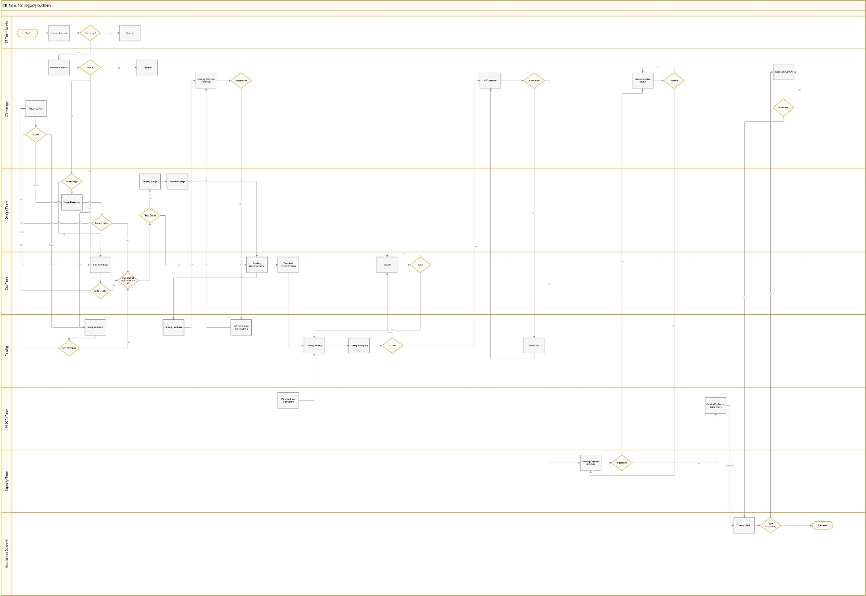

Ongoing Child CR WF
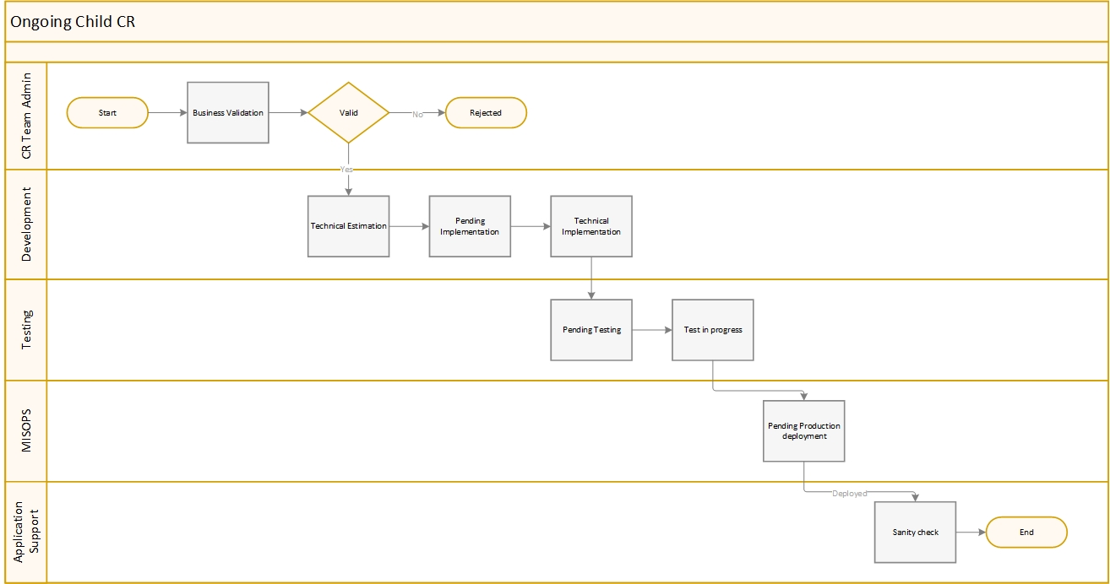

Vendor CR
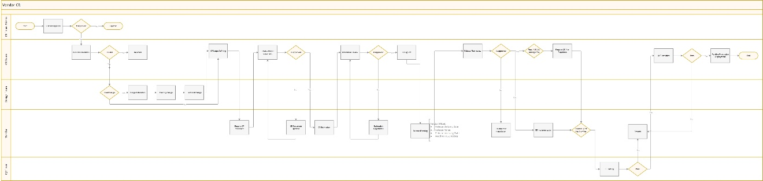

Notes
- Technical status available for each group & work flow attached.

Caution: these statuses & groups are variable and can be changed according to business need.

- Technical fields which will appear in the CR page after submission and will be visible to technical teams only for all statuses & groups attached.
- Groups & pages permissions attached.

Technical Feedback
Action | Date | Responsible | Notes

References, supporting docs and approvals:

